## ­­Exercise 4.1: Recipe Book: Add a Menu to Start a new Activity

On clicking a menu entry on the *App Bar* in the recipe list, the create recipe activity should be open.

Proceed as follows:

1. Add an *App Bar* as shown during the lecture.
2. Create a menu and menu entry as shown during the lecture (chapter 4).
3. In the method RecipeListActivity.onOptionsItemSelected() create and invoke an *Intent* to start the new *Activity*.

Remark:

* Remember to only set your main activity (Recipe List) as  
    
  in *AndroidManifest.xml* if you changed this before.

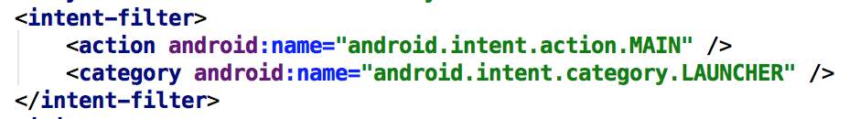

Maps or any other maps app) with the country shown.

## Exercise 4.2: Show Country on Map (Recipe Details)

Extend the activity that shows recipe details. On click on the country text there should appear a map (in Google Maps or any other maps app) with the country shown.

## Exercise 4.3: Open the Recipe Details activity on item click from the Recipe List

Extend the Recipe List activity by adding an OnItemClickListener to the list view. When you click on an item from the list, load the corresponding recipe inside the details activity.

## Exercise 4.4: Add an Intent to open the newly created Rrecipe

After creating a Recipe, create an intent to open a new activity with details about the newly created Recipe.

## Exercise 4.5: Include Share-Button (Recipe Details)



In this exercise you will extend the recipe details activity with a „share“-button. The recipe information can be shared with other apps.

For the *App Bar* there is a standard approach to include this functionality:

1. Add this item to your *menu.xml*:

<**item android:id="@+id/action_share" android:title="Share"  
 app:showAsAction="ifRoom"  
 app:actionProviderClass="androidx.appcompat.widget.ShareActionProvider"** />

1. **Extend the method** RecipeDetails.onCreateOptionsMenu() **similar to what is shown below:**

@Override  
**public boolean** onCreateOptionsMenu(Menu menu) {  
 getMenuInflater().inflate(R.menu.***menu_main***, menu);  
  
 MenuItem shareItem = menu.findItem(R.id.***action_share***);  
 **shareActionProvider** = (ShareActionProvider)   
 MenuItemCompat.*getActionProvider*(shareItem);  
 setShareText(**null**);  
  
 **return true**;  
}  
  
**private void** setShareText(String text) {  
 Intent shareIntent = **new** Intent(Intent.***ACTION_SEND***);  
 shareIntent.setType(**"text/plain"**);  
 **if** (text != **null**) {  
 shareIntent.putExtra(Intent.***EXTRA_TEXT***, text);  
 }  
  
 **shareActionProvider**.setShareIntent(shareIntent);  
}

1. Always call setShareText() to update the share intent when the currency conversion result changes!
2. Starting with Android 11 you have to add the following to AndroidManifest.xml to really see all share targets[1]:

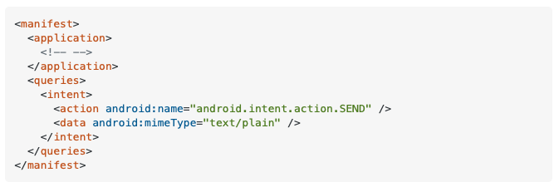

1. See <https://stackoverflow.com/a/64777763>